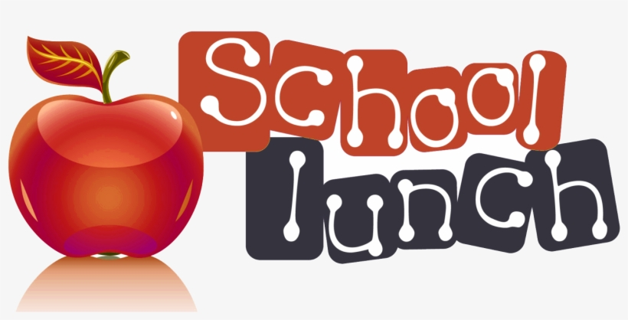

17th September 2025

Dear Parents of YR6,

We are writing to invite you to have lunch with your child on **Monday 20th October 2025.**

You are most welcome to bring in your own packed lunch, please support us by bringing a healthy packed lunch and not food from a Fast Food outlet. Alternatively, you can pre-order a school meal from the kitchen. We would be grateful if you could choose your option and complete the cut off slip below. Please return the slip **no later** than **Friday 10th October 2025**, along with your payment if you wish the kitchen to provide your meal.

We look forward to seeing you on **Monday 20th October 2025**. Please arrive at school no later than **11.55am**, to be shown to the school hall where your child will join you for lunch.

This lunch date is not an opportunity to meet with your child’s teacher or to visit the classroom to look at your child’s work. The event is purely designed for parents to dine with their child/children in the school environment. After lunch you are more than welcome to go to the playground with your child for 15 minutes.

Yours sincerely,

Paola Burgess

Head Teacher

**YEAR 6 PARENTS LUNCH –Monday 20th October 2025**

Childs Name------------------------------------------------------ Class-----------------------

Number of Adults attending--------------------- Choose an option below:

Option 1. □ Char Sui Pork with Noodles £3.84

Option 2. □Chow Mein Noodles £3.84

Option 3. □ Penne Pasta with Homemade Tomato Sauce £3.84

Option 4. □ Jacket Potato with cheese, beans or tuna mayonnaise £3.84

Option 5. □ Bringing my own PACKED LUNCH