Pupil premium strategy statement- Grange Community Junior School 2025-26


This statement details our school’s use of pupil premium funding to help improve the attainment of our disadvantaged pupils.

It outlines our pupil premium strategy, how we intend to spend the funding in this academic year and the effect that last year’s spending of pupil premium had within our school.

School overview
Detail | Data
Number of pupils in school | 239
Proportion (%) of pupil premium eligible pupils | 29%
Academic year/years that our current pupil premium strategy plan covers (3 year plans are recommended) | 2023-2026
Date this statement was published | September 2023
Date on which it will be reviewed | Spring 2026
Statement authorised by | Paola Burgess
Pupil premium lead | Lyn Williams and Paola Burgess
Governor / Trustee lead
Funding overview
Detail | Amount
Pupil premium funding allocation this academic year | £115,140
Recovery premium funding allocation this academic year | £0
Pupil premium (and recovery premium*) funding carried forward from previous years (enter £0 if not applicable)  *Recovery premium received in academic year 2021 to 2022 can be carried forward to academic year 2022 to 2023. Recovery premium received in academic year 2022 to 2023 cannot be carried forward to 2023 to 2024. | £0
Total budget for this academic year  If your school is an academy in a trust that pools this funding, state the amount available to your school this academic year | £115,140

Part A: Pupil premium strategy plan

Statement of intent
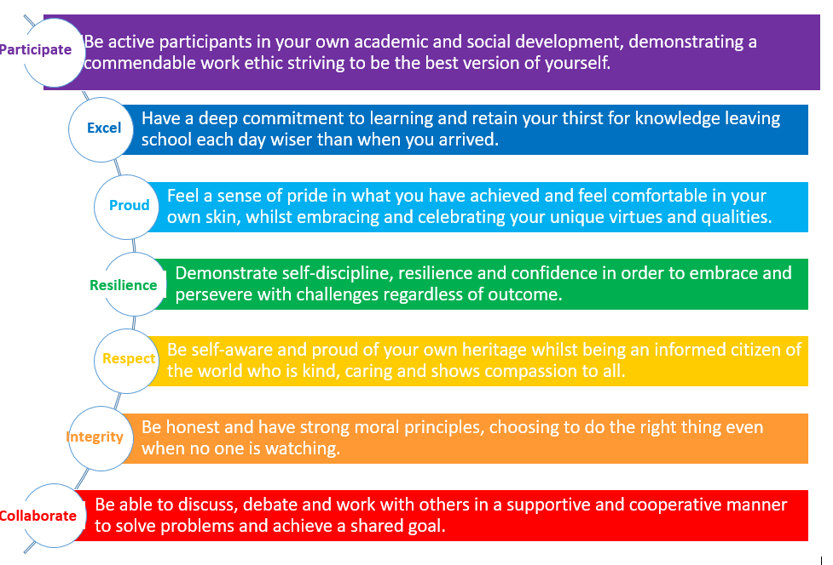
At Grange Junior School, our school ethos of ‘Where Everyone Counts” is a core, fundamental belief that resonates through everything we do. This ethos is rooted in our understanding that all pupils, regardless of their background, should have access to quality teaching which allows them to improve their attainment.
For us, at Grange, our school values underpin the attributes we believe support pupils to both learn effectively and to make positive contributions to our society and the world around them.
Essentially, our ultimate aim is for all pupils to be successful in the future, and to prepare them so that they are able to make positive contributions to our society and the world around them. At Grange Juniors we have a particular focus on ensuring that pupils will have literacy and numeracy skills which will support them in their next steps of learning.
At the heart of our approach is investment into high-quality teaching as we know that this is the most significant factor in raising academic achievement. This is proven to have the greatest impact on closing the disadvantage attainment gap and at the same time will benefit the non-disadvantaged pupils in our school. Where additional intervention is required, including those with EHCPs, this is planned, delivered and evaluated in order to judge impact and ensure progress. Our actions are rooted in diagnostic assessment, followed by whole class and group strategies to close the gaps identified.
The Covid Pandemic and continued cost of living crisis has had an impact on ALL pupils at school. Negative impacts may have been caused by a number of factors during this time; household poverty and living conditions; mental health and wellbeing; family related challenges; physical health; increased exposure to harm; nutritional needs; reduced access to education and activities. At Grange, we have considered these challenges faced by our most vulnerable pupils. The activity we have outlined in this statement is also intended to support their needs, regardless of whether they are disadvantaged or not. Implicit in the intended outcomes detailed below, is the intention that non-disadvantaged pupils’ attainment will be sustained and improved alongside progress for their disadvantaged peers.
At Grange Junior School our intent for the pupil premium strategy is to endeavour to ensure:
- The barriers to learning are carefully identified.
- The pupil premium funded activities are appropriate for overcoming these barriers. Activities that are planned, and delivered are informed by evidence.
- Activities are monitored for quality and impact and changes are made as necessary.

Challenges

This details the key challenges to achievement that we have identified among our disadvantaged pupils.
Challenge number | Detail of challenge
1. | Our assessments and observations indicate that the education and wellbeing of many of our disadvantaged pupils was impacted by the pandemic.  Our assessments, observations and discussions with pupils and families have identified difficulty for some with socialising, development of executive functioning/self-regulation skills, language skills and social, emotional and mental health issues.  Disrupted home circumstances, have had an impact on anxiety, social integration and learning. The cost of living crisis has increased pressure on our vulnerable families.  Safeguarding monitoring indicates 93% of disadvantaged children have CPOMS notifications linked to behaviour/attendance/medical/SEMH needs  Referrals for a range of support continue to increase with many of the families supported by our school counsellor, ELSA and the mental health support team are disadvantaged.
2. | All of the issues above have also impacted on attendance for some and has been further exacerbated by the current cost of living crisis and the additional pressures this has brought to home life for these pupils. These findings are supported by national studies and has resulted in significant knowledge gaps leading to pupils falling further behind age-related expectations.
3. | Assessments and observations indicate very low baseline entry levels in language development – (which has an impact on reading & writing skills) and numeracy. These low starting points have an impact across the 4 years of junior school (and in future years).  On entry to year 3 2025-26  On entry to year 3 sept 2025-26 50% of disadvantaged children did not pass phonic screening in year 1  On entry in Sept 2025  37% dis children achieved ARE in READING  __% of dis children achieved ARE in WRITING – not assessed until December  37% of dis children achieved ARE in MATHS  On entry to year 3 2024-25  On entry to year 3 sept 2024-25 71% of disadvantaged children had gaps in their phonic knowledge  47% of the disadvantaged children failed the language link screening test Sept 2024.  On entry in Sept 2024  29% dis children achieved ARE in READING  24% of dis children achieved ARE in WRITING  35% of dis children achieved ARE in MATHS  On entry to year 3 sept 2023-24 100% of disadvantaged children had gaps in their phonic knowledge  41% of the disadvantaged children failed the language link screening test Sept 2023-24  On entry in Sept 2023-24  16% dis children achieved ARE in READING  15% of dis children achieved ARE in WRITING  18% of dis children achieved ARE in MATHS  18% of dis children achieved ARE for SPELLING  POOR PHONIC KNOWLEDGE  On entry to school all year 3 children, screen for phonic knowledge. Some Year 3 children have notable gaps in their phonics knowledge. This negatively affects their development as a reader and writer.  In 2022-3 only 69 % of pupils passed their phonics screen in year 1. This rises to 87% in year 2.  2023-24 57% of pupils passed their phonics screen in year 1. This rises to 66% in year 2.  2024-5 56% of pupils passed their phonics screen in year 1. This rises to 89% in year 2.  2025-6 52% of pupils passed their phonics screen in year 1. This rises to 58% in year 2  READING disadvantaged pupils start of year 25-26  Year 3 59% below ARE  Year 4 58% below ARE  Year 5 56% below ARE  Year 6 20% below ARE  WRITING disadvantaged pupils start of year 25-26  Year 3 64% below ARE  Year 4 41% below ARE  Year 5 68% below ARE  Year 6 30% below ARE  MATHS disadvantaged pupils start of year 25-26  Year 3 64% below ARE  Year 4 64% below ARE  Year 5 50% below ARE  Year 6 25% below ARE
4. | Transition data, assessments, and observations are showing that there are high and growing numbers of pupils with SEND. A high proportion of disadvantaged pupils are doubly disadvantaged with a SEND too.  Start of year 25-26 % of disadvantaged pupils with SEND  Y3 – 24%  Y4 – 47%  Y5 – 44%  Y6 – 45%  Start of year 24-25 % of disadvantaged pupils with SEND  Y3 -61% SEN  Y4-44% SEN  Y5-45% SEN  Y6 -40% SEN  (Note that some pupils on the SEN register come off as they go through the school)
5. | The lack of opportunity to engage in experiential learning outside of school including after school clubs, trips and visits due to family financial circumstances is a potential barrier to disadvantaged pupils reaching their potential across the curriculum.

Intended outcomes (over 4 years)
This explains the outcomes we are aiming for by the end of our current strategy plan 2023-26, and how we will measure whether they have been achieved.
Intended outcome | Activity that supports this | Evidence that supports this approach | Challenge number(s) addressed
Improvements to academic learning  Improvements to pupil wellbeing  Development of SE skills and attitudes that promote learning  Prevention of mental health problems  Improvements in school behaviour  Reduction in extreme behaviour such as impulsive, anger, bullying | Whole school approach to promote wellbeing including policies and practices  Preventative and pastoral work ELSA. TALA  Preventative work e.g. PHSE  Preventative work teaching SE skills and attitudes in positive classes | National Children’s Bureau  https://www.ncb.org.uk/sites/default/files/uploads/files/ncb  _framework_for_promoting_well-being_and_responding_to_mental_health_in_schools_0.pdf  EEF SEL | 1-5
Improved attendance | Whole school approach to attendance:  Build a culture of community  Ensure that provision for pupils in class supports their learning needs  Tracking system to understand specific issues  Working with families including working with external agencies | EEF attendance  https://educationendowmentfoundation.org.uk/education-evidence/leadership-and-planning/supporting-attendance  EEF Guide to Pupil Premium – Tiered Approach (p.5). Pupils are identified whose attendance and punctuality needs to improve. The Attendance Team meets regularly to evaluate the impact of actions as a result of these meetings in order to eliminate weak attendance.  Bradford research school  https://researchschool.org.uk/bradford/news/attendance-beyond-the-percentage | 2
Improve language and communication for those below expected levels  CPD - Increased knowledge and confidence of staff in strategies to support pupils SLC  Pupils can articulate ideas before writing  Pupils vocabulary extends (see class tracker)  Increased score in BPVS  Increased score in any intervention used | Whole school approach: Using visual supports, clear language, teaching collaboration and participation  Teaching vocabulary and spelling linked to other curriculum areas.  Teaching and modelling vocabulary and language and reading and writing  Collaborative activities that support speaking and listening  Focus on vocabulary – explicit teaching to help pupils retain and use new vocabulary  Use interventions/specialist support e.g. Talk boost/preteach of vocab | National Educational Psychology Service  https://assets.gov.ie/41296/283 e60e2a902464bb684e8faaa007267.pdf  EEF language approaches  https://educationendowmentfoundation.org.uk/early-years/toolkit/communication-and-language-approaches  Word reading and language comprehension are underpinned by a number of other building blocks. The foundations of literacy include oral language and cognitive processes that underpin writing.  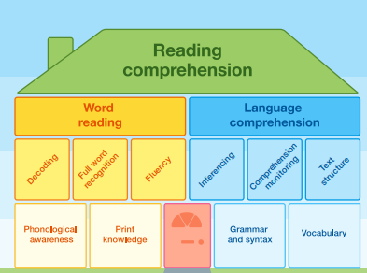 | 3
CPD - Increased knowledge and confidence of staff in strategies to support pupils with phonics/reading  Improved accuracy of reading improved PIRA scores  Improved fluency of reading (fluency scale?)  Improved comprehension of reading SS scores on NFER or reading intervention | Whole school approach to reading: policy and practice with a balance of decoding and comprehension. Guided reading to increase fluency. Including pupils listening to adults reading  Explicit/systematic teaching of phonics match to children’s current level  Explicit teaching of reading comprehension strategies through modelled and supported practice  Phonic interventions  Regular reading (with adults) | EEF improving literacy in KS2  https://d2tic4wvo1iusb.cloudfront.net/production/eef-guidance-reports/literacy-ks2/EEF-Improving-literacy-in-key-stage-2-report-Second-edition.pdf?v=1730899380  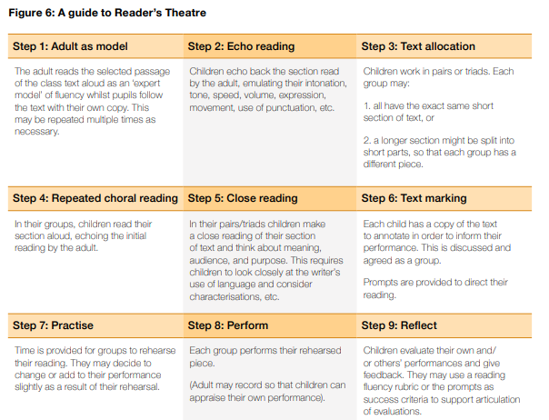 | 3
CPD - Increased knowledge and confidence of staff in strategies to support pupils with writing  Formation of letters accurately  Spelling correctly of HF words, weekly spelling words  Improving knowledge of and using correct punctuation  Improvement to writing composition in line with target including sentence structure, grammar, punctuation, composition  Improvement to writing in engaging the audience | Explicit teaching of writing strategies planning, drafting, revising, editing, publishing  Explicit teaching of transcription – handwriting and spelling and grammar to free cognitive load for writing composition  Diagnostic assessment used to inform next steps and intervention  Effective teacher feedback to improve writing  Intervention support | EEF writing  https://educationendowmentfoundation.org.uk/education-evidence/guidance-reports/literacy-ks2 | 3
CPD - Increased knowledge and confidence of staff in strategies to support pupils with maths  Pupils are able to communicate their reasoning  Pupils are able to recall facts automatically so enable them to problem solve. Improvement in x tables knowledge  Improvement in SS score for maths | Diagnostic assessment used to inform next steps and intervention  Use CPA approach  Sequenced small steps of learning  Explicit teaching of strategies for problem solving  Explicit teaching of maths related vocabulary  Tasks and resources that challenge and support to build conceptual and procedural knowledge  Intervention support | EEF Maths  https://d2tic4wvo1iusb.cloudfront.net/production/eef-guidance-reports/maths-ks-2-3/EEF-Improving-Mathematics-in-Key-Stages-2-and-3-2022-Update.pdf?v=1730901305  Coordinating mathematical success dfe  https://www.gov.uk/government/publications/subject-report-series-maths/coordinating-mathematical-success-the-mathematics-subject-report  There is strong evidence both nationally and within the school historically (KSII disadvantaged Maths data 2019) that reducing group size with bespoke focus on eliminating gaps and precision teaching with experienced professionals improves the progress of all pupils including disadvantaged.  https://educationendowmentfoundation.org.uk/education -evidence/teaching-learning-toolkit/small-group-tuition | 3
CPD - Increased knowledge and confidence of staff in strategies to support pupils with Adapting support to pupil needs  Improved progress score (by whichever means measuring progress)  Targets achieved on Provision mapping  Improved SS where applicable | Create a positive, inclusive learning environment to support pupil needs  Focus on individual learning needs: barriers, strengths, access strategies, school provision  High quality teaching to support all pupils  Intervention support  Effective deployment of support staff who work with pupils with SEND  Continued provision of digital; technology & resources to aid attainment and intervention | Pupils with Special Educational Needs and Disability (SEND) have the greatest need for excellent teaching and are entitled to provision that supports achievement at, and enjoyment of, school. The attainment gap between pupils with SEND and their peers is twice as big as the gap between pupils eligible for free school meals and their peers. However, pupils with SEND are also more than twice as likely to be eligible for free school meals.  https://educationendowmentfoundation.org.uk/education-evidence/guidance-reports/send  Pupils are identified by who we believe would benefit from additional support from a teaching assistant. On selected afternoons, Learning Support Assistants then deliver carefully selected programs based on the needs identified. The frequency is dependent upon the requirements of the specific programme.  National literacy trust https://literacytrust.org.uk/education-recovery/interventions/  https://educationendowmentfoundation.org.uk/support-for-schools/school-planning-support/2-targeted-academic-support  Small group tuition is most likely to be effective if it is targeted at pupils’ specific needs.  Teaching Assistant Interventions (EEF+4) Reading Comprehension strategies (EEF+6)  https://www.theschoolpsychologyservice.com/what-works/  What works for literacy difficulties  EEF SEN  https://d2tic4wvo1iusb.cloudfront.net/production/eef-guidance-reports/send/EEF_Special_Educational_Needs_in_ Mainstream_Schools_Guidance_Report.pdf?v=1730898017 | 4
Ensure that we have provided a range of opportunities through the curriculum to extend disadvantaged pupil’s cultural capital and personal qualities.  An increase in participation in enrichment activities, particularly among disadvantaged pupils | Broad and effective curriculum that support pupils to be educated citizens with a growing knowledge of culture, books, the arts, language, attitudes, emotional skills  Subsidising class tips/visits to improve cultural capital.  Financial support with wider experiences in the Curriculum, before and after school clubs. Ensuring provision for targeted Free breakfast club, extra-curricular clubs & uniform | The curriculum is broadly ‘everything that happens to a child in school’, we plan ways in which skills and personal qualities can be developed alongside knowledge.  Ensuring that disadvantaged children and those who have fewer opportunities to develop skills outside of school are able to access our wider curriculum including experiences which are fundamental to our school vision of inclusion  Building cultural capital in disadvantaged pupils  https://www.governmentevents.co.uk/wp-content/uploads/2021/02/Steve-moffitt.pdf

Activity in this academic year 2025-26
This details how we intend to spend our pupil premium (and recovery premium funding) this academic year to address the challenges listed above.

Teaching (for example, CPD, recruitment and retention)
Budgeted cost: £ 60,000
Intended outcome | Activity | Evidence that supports this approach | Success criteria | Cost | Challenge number(s) addressed
Improved PPG strategy to better support disadvantaged learners in achieving improved outcomes | Attendance of senior leaders at Hampshire Pupil Premium strategy meetings  Administration relating to pupil premium | EEF guide to the pupil premium  https://educationendowmentfoundation.  org.uk/education-evidence/using-pupil-premium | - Robust PP strategic written  - Pupils entitled to PP who are not SEN show positive gains | PPG training £90 LW/PB | 1-5
Disadvantaged pupils make accelerated progress in reading, narrowing the gap with their peers.  A higher proportion of PP pupils achieve expected standard or above in statutory assessments.  More PP pupils achieve Greater Depth/working at a higher level, demonstrating higher-level comprehension skills.  Disadvantaged pupils read more frequently, both in class and at home. | Whole school approach reading pupil progress and assessment  Phonics screen.  Use of additional adults for pupils who do not read at home  CPD –EB HIAS English and English course  Disseminated reading pedagogy staff training at twilight session  Reading at homework club and at reading club at lunchtime  Employment of designated reading teacher  Reading leader given SL time to work on action plan | EEF improving literacy in KS2  https://d2tic4wvo1iusb.cloudfront.net/production/eef-guidance-reports/literacy-ks2/EEF-Improving-literacy-in-key-stage-2-  report-Second-edition.pdf?v=1730899380  https://educationendowmentfoundation.org.  uk/educationevidence/teaching-learning-toolkit/phonics | - Progress in reading SS for disadvantaged pupils  - Improvement is phonic levels for Dis pupils  - Progress in book bands +2 for Dis Pup  - Disadvantaged pupils reading 3+x a week at home/school | Totals  £640 Maths& £640 English HIAS (part payment for the Dis children)  Part payment SENCO – CPD £4069  FJ (0.5 of her time) payment £7642  EB 3 days SL time £633 | 3
Disadvantaged pupils make accelerated progress in writing, narrowing the attainment gap with peers.  A higher proportion of PP pupils achieve expected standard or above in statutory assessments.  More PP pupils reach Greater Depth/working at a higher standard where appropriate.  Pupils are better prepared for the next stage of education, with strong literacy skills supporting overall academic progress. | CPD – HW HIAS writing  Writing leader given SL time to work on action plan  HW lead CPD twilight -Writing development  RW to attend Year 6 expectations CPD  Continue to use spelling Shed as a programme to support all pupils with spelling  2x English team attend oracy and drama CPD | EEF writing  https://educationendowmentfoundation.org.  uk/education-evidence/guidance-reports/literacy-ks2 | - Improvements in spelling scores SS for dis pup  - Improved SPAG SS for dis pup  - Improvements in GAMS for dis pup working towards ARE | Total  Spelling Shed £337.25  HIAS Writing- EB £(see above)  RW to attend Year 6 expectations CPD £205  EB 3 days SL time £ as above  Oracy EB and RW £100 | 3
Disadvantaged pupils make accelerated progress, narrowing the gap with peers.  A higher proportion of PP pupils achieve expected standard or above in statutory assessments.  More PP pupils reach Greater Depth/working at higher levels, demonstrating mastery and problem-solving skills. | CPD – CR attend HIAS Maths  Disseminated Maths pedagogy staff training at twilight session  Use of PUMA maths testing as a diagnosis for issues in maths  RW to attend Year 6 standardisation CPD  Maths leader given SL time to work on action plan | https://educationendowmentfoundation.org.  uk/educationevidence/guidance-reports | - Progress in Maths SS for disadvantaged pupils  - Improvements in X tables for dis pup  - Improved reasoning through higher percentage of pupils attaining reasoning questions | Total  HIAS Maths (accounted for in previous details)  PUMA credits (25) £63  RW to attend Year 6 standardisation CPD £230 | 3
Pedagogy  CPD - Increased knowledge and confidence of staff in strategies to support pupils  CPD raises the quality of teaching to promote improved attainment  Improved pupil outcomes | Weekly CPD training sessions revisiting pedagogy for teachers and LSA  Weekly year team meeting at the start of the week to ensure that all staff know exactly what they should be doing  All staff to attend AI in the curriculum whole day INSET – how can AI enhance teaching and learning | Supporting high quality teaching is pivotal in improving children’s outcomes. Indeed, research tells us that high quality teaching can narrow the disadvantage gap.  https://educationendowmentfoundation.org.  uk/educationevidence/teaching-learning-toolkit/behaviourinterventions | - Attendance of all teaching and LSA staff at weekly pedagogy sessions  - Learning walks show quality teaching provision | Educational supplies - £8500  TT Rockstars £120
Cultural capital  Ensure that we have provided a range of opportunities through the curriculum to extend disadvantaged pupil’s cultural capital and personal qualities.  An increase in participation in enrichment activities, particularly among disadvantaged pupils | LB attend Music training  Music, art, French, DT, Geography, PE, Computing, Science leader given SL time to work on action plan  RLB to attend Geography cluster CPD event  Additional events for school attended  Project home works set up to ensure pupils expand knowledge of the world  School trips and enrichment subsidised  Societies  Homework club to support self study | The curriculum is broadly ‘everything that happens to a child in school’, we plan ways in which skills and personal qualities can be developed alongside knowledge.  Ensuring that disadvantaged children and those who have fewer opportunities to develop skills outside of school are able to access our wider curriculum including experiences which are fundamental to our school vision of inclusion  Building cultural capital in disadvantaged pupils  https://www.governmentevents.co.uk/wp-content/uploads/2021/02/Steve-moffitt.pdf | - Cultural arts in school extended  - 70-80% ARE in foundation subjects  - Increased number of children attend enrichment clubs | Totals  LB music £70  £223 – HIAS geography training (part)  3 days per SL cover SL time £633  £150 subsidy of trips & enrichment | 5

Targeted academic support (for example, tutoring, one-to-one support structured interventions)
Budgeted cost: £ 50,000
Intended outcome | Activity | Evidence that supports this approach | Success criteria | Cost | Challenge number(s) addressed
SEN  CPD - Increased knowledge and confidence of staff in strategies to support pupils with Adapting support to pupil needs  Improved progress score (by whichever means measuring progress)  Targets achieved on Provision mapping  Improved SS where applicable | Staff CPD (see teaching section)  Training on formative assessment, explicit instruction and feedback  Reading support teacher FJ  Grouped reading across lower school to ensure all pupils working at their correct level  Diagnostic assessment + progress monitoring system  Pupil progress meetings to define support for targeted children.  Targeted academic support through formative assessment to ensure that all pupils are working at correct level and being challenged. Use of recap and sticker tasks to offer immediate feedback and clarify misconceptions  1:1 tutoring for one pupil who is home schooled.  Year 6 SATs booster groups | There is strong evidence both nationally and within the school historically that reducing group size with bespoke focus on eliminating gaps and precision teaching with experienced professionals improves the progress of all pupils including disadvantaged.  https://educationendowmentfoundation.org.  uk/educationevidence/teaching-learning-toolkit/small-group-tuition  https://educationendowmentfoundation.org.  uk/educationevidence/teaching-learning-toolkit/teaching-assistantinterventions | - All disadvantaged pupils with SEN are in receipt of support/intervention  - Improved progress score (by whichever means measuring progress)  - Targets achieved on Provision mapping  - Improved SS where applicable | Total  Reading LSA £ as above  Boosters  £235  Part payment of SENCo work  £23,583  2x week HW and 2x week MS £180 per wk  (£8,000) | 3,4
More able pupils achieve Greater Depth Standard (GDS) in statutory assessments or demonstrate accelerated progress against baselines. | Targeted CPD work with staff to challenge more able learners | EEF Toolkit – Targeted Academic Support: identifies that high-attaining disadvantaged pupils are at risk of underachievement if not given appropriately challenging work.  The DfE’s “Pupil Premium: Guide for School Leaders” (2023) highlights the need to identify more able PP pupils and plan interventions to ensure they reach the top bands.  The Sutton Trust and EEF highlight that high-quality, appropriately challenging teaching benefits all pupils, and is particularly important for higher-attaining disadvantaged children. | - Teachers routinely provide differentiated tasks with higher-level questioning and open-ended challenges.  - Lesson observations and learning walks show more able pupils are consistently given opportunities to extend their thinking (e.g., problem-solving, reasoning, creative application). | Subject leader time given to all teachers-  £18,372

Wider strategies (for example, related to attendance, behaviour, wellbeing)
Budgeted cost: £ 20,000
Intended outcome | Activity | Evidence that supports this approach | Success criteria | Cost | Challenge number(s) addressed
Attendance and wellbeing are core to being able to benefit from academic interventions
Improvements to pupil wellbeing  Development of SE skills and attitudes that promote learning  Support to pupils to manage their own emotions | Whole school approach to promote wellbeing including policies and practices revisit of golden threads/values for staff and in assemblies for children. Also review golden threads and the curriculum in staff CPD sessions  Weekly use of Trick Box.  Preventative and pastoral work ELSA. TALA  Preventative work e.g. PHSE  Teachers and LSAs CPD using sensory circuits. No fixed cost. Purchase of equipment for sensory circuits.  Introduction of Forest School. Forest school equipment. | National Children’s Bureau  https://www.ncb.org.uk/sites/default/files/ uploads/files/ncb  _framework_for_promoting_well-being_and_responding_to_mental_health_in_schools_0.pdf  EEF SEL | - Building self-esteem and confidence  - Building teamwork & cooperation  - Build conflict resolution  - Stress reduction: Being in nature lowers stress and anxiety, promoting calmness and relaxation. | Totals  ELSA (LF) -£355  Mary  £4400  Sensory circuits equipment £300  Forest school level 3 CPD  £1500  Forest school equipment £2,000 | 1 and 2
Staff equipped to effectively manage with serious behaviour incidents | Teachers and LSAs CPD from PBS practice working with children affected by trauma. No fixed cost.  1 x staff team teach training | EEF – Improving Behaviour in Schools Guidance Report (2019)  Key recommendation: “Promoting good behaviour means recognising positive behaviours as well as responding to poor behaviour.”Evidence shows that a consistent, whole-school approach is more effective than isolated strategies. Behaviour interventions have a moderate positive impact (+4 months progress on average). | - Trained staff report increased confidence in de-escalation strategies  - Lesson observations show pupils following routines calmly (e.g., transitions, lining up, settling quickly).  - Pupils demonstrate increased on-task behaviour (measured via learning walks or structured observations).  - Pupils most at risk of exclusion show improved attendance, engagement, and progress. | Team teach LF  £165
Improved attendance for those below 95% | Early-help attendance officer for home-school liaison, engagement incentives for targeted pupils. | EEF attendance  https://educationendowmentfoundation.org.uk/education-evidence/leadership-and-planning/supporting-attendance  EEF Guide to Pupil Premium – Tiered Approach (p.5). Pupils are identified whose attendance and punctuality needs to improve. The Attendance Team meets regularly to evaluate the impact of actions as a result of these meetings in order to eliminate weak attendance.  Bradford research school  https://researchschool.org.uk/bradford/news/attendance-beyond-the-percentage | - Improved attendance  for targeted pupils | Total  Part payment attendance/ family worker £6,000 | 2
Removes barriers at home and increases learning time for disadvantaged pupils. | Homework club / supervised study + resources. Sessions with staff to complete and improve homework | DfE guidance emphasises addressing wider barriers. | - Pupil spend additional time in school with teachers to work on homework tasks.  - Home learning opportunities not missed |  | 3 4
Intended outcome | Success criteria | Review/Impact
Improved PPG strategy to better support disadvantaged learners in achieving improved outcomes | - Robust PP strategic written  - Pupils entitled to PP who are not SEN show positive gains | LLP report April 2025: Leadership at all levels is strong. There is a shared determination to provide an ambitious and relevant curriculum which builds cultural capital and prioritises reading for all children, particularly the most vulnerable.  An established inclusive culture is in place where leaders at all levels are clear of their responsibility to provide a rich educational experience for all pupils. Following leaders’ forensic analysis of data to identify gaps in learning, White British children are also included as a vulnerable group.
   | No. | Reading |  | Writing |  | Maths |  | RWM
  Group | 60 | School | National | School | National | School | National | School | National
  All | 60 | 86% | 75% | 83% | 72% | 88% | 74% | 73% | 62%
  Disad | 20 | 75% | 60% | 65% | 53.4% | 85% | 56.4% | 65% | 40.9%
  FSM | 20 | 75% | 60% | 65% | 53.4% | 85% | 56.4% | 65% | 40.9%
CPD - Increased knowledge and confidence of staff in strategies to support pupils with phonics/reading  Improved accuracy of reading  Improved fluency of reading  Improved comprehension of reading | • Progress in reading SS for disadvantaged pupils  • Improvement is phonic levels for Dis pupils  • Progress in book bands +2 for Dis Pup  • Disadvantaged pupils reading 3+x a week at home/school  • Improvements in PIRA for dis pup | LLP report April 2025: Reading is a priority for the school. Pupils spoken to on the day of the visit enjoy reading and are knowledgeable of a wide range of high quality texts. A consistent approach to the structures and routines within guided reading lessons ensure that the teaching of vocabulary is explicit. Clear targets are in place for pupils who are at risk of not reaching age related expectations (ARE) and additional reading sessions including phonic groups and volunteer readers support the class lessons. As a result, children can decode and comprehend a wide range of complex texts and can articulate with confidence the key components needed to  continue to successfully develop their reading skills.  Ofsted Deep Dive into Reading April 2025 :The curriculum is well embedded and plans to ensure all pupils are fluent readers. Reading for pleasure is also planned for. Staff have had training on phonics and staff are clear about the guided reading system, clearly knowing what they are doing.  Disadvantaged 24-25 % ARE aut-Sum Pupils made good progress across the year 2024-25  Notes  Year 4 gained 4 new children all of whom are working below standard in Spring term  Year 5 gained 1 new pupil working below standard in Spring term
   |  | dis % ARE+  17 chn  Aut | Spr | Sum | dis % GD  Aut | Spr | Sum | dis  no SEN  % ARE+  9 children  Aut | Spr | Sum | dis GD  no SEN % ARE+  Aut | Spr | Sum
  Y3 | Reading | 29% | 29% | 35% | 5% | 5% | 11% | 55% | 55% | 55% | 11% | 11% | 22%
  Y3 | Writing | 22% | 27% | 29% | 0% | 0% | 0% | 50% | 55% | 55% | 0% | 0% | 0%
  Y3 | Maths | 33% | 33% | 35% | 5% | 11% | 11% | 66% | 66% | 66% | 11% | 22% | 22%
  Y4 | Reading | 33% | 35% | 47% | 7% | 6% | 11% | 67% | 67% | 72% | 11% | 11% | 18%
  Y4 | Writing | 6% | 24% | 35% | 0% | 0% | 0% | 6% | 44% | 54% | 0% | 0% | 0%
  Y4 | Maths | 38% | 41% | 64% | 0% | 0% | 11% | 75% | 77% | 81% | 0% | 0% | 18%
  Y5 | Reading | 72% | 72% | 83% | 11% | 15% | 22% | 90% | 90% | 91% | 18% | 27% | 28%
  Y5 | Writing | 60% | 65% | 77% | 0% | 0% | 0% | 91% | 91% | 85% | 0% | 0% | 0%
  Y5 | Maths | 41% | 70% | 83% | 15% | 15% | 27% | 73% | 73% | 74% | 18% | 27% | 35%
  Y6 | Reading | 70% | 70% | 76% | 35% | 35% | 23% | 100% | 100% | 100% | 50% | 50% | 31%
  Y6 | Writing | 65% | 65% | 76% | 5% | 5% | 5% | 90% | 90% | 84% | 10% | 10% | 7%
  Y6 | Maths | 60% | 65% | 92% | 10% | 10% | 35% | 90% | 100% | 100% | 20% | 20% | 46%
   | No. | Reading ARE+ Y6 Disadvantaged
  Group | 60 | School | National
  All | 60 | 86% | 75%
  Disad | 20 | 75% | 60%
  FSM | 20 | 75% | 60%
CPD - Increased knowledge and confidence of staff in strategies to support pupils with writing  Formation of letters accurately  Spelling correctly of HF words, weekly spelling words  Improving knowledge of and using correct punctuation  Improvement to writing composition in line with target including sentence structure, grammar, punctuation, composition  Improvement to writing in engaging the audience | - Improvements in handwriting letters for dis pup  - Improvements in spelling scores for dis pup  - Improved SPAG SS for dis pup  - Improvements in GAMS for dis pup | Deep dive writing Ofsted April 2025  There is a very ambitious writing curriculum which starts at greater depth and is scaffolded down. The curriculum uses authors work well to support learning. It was clear to see progression in books and how scaffolding was used well to support pupils with SEND.
   | No. | SPAG
  Group | 60 | School | National
  All | 60 | 85% | 72.6%
  Disad | 20 | 75% | 59.7%
  FSM | 20 | 75% | 59.7%
   | No. | Writing
  Group | 60 | School | National
  All | 60 | 83% | 72%
  Disad | 20 | 65% | 53.4%
  FSM | 20 | 65% | 53.4%
Maths  Improved Maths attainment and progress among disadvantaged pupils. Pupils’ are equipped with a range of strategies for problem solving and the ability to reason in maths improves, so that the percentage of pupils attaining ARE+ improves. | • Progress in Maths SS for disadvantaged pupils  • Improvements in X tables for dis pup  • Improved reasoning through higher percentage of pupils attaining reasoning questions | Ofsted maths: The curriculum is ambitious for all pupils including SEND. There is a baseline assessment for all pupils. Planning follows the NC and HIAS and is well structured. Staff adapt planning to suit the needs of pupils. There is a yearly overview which is annotated. Staff adapt teaching based on AFL.
   | Maths ARE+ y6 2025 Disadvantaged pupils
   | School | National
  All | 88% | 74%
  Disad | 85% | 56.4%
  FSM | 85% | 56.4%
Pedagogy  CPD - Increased knowledge and confidence of staff in strategies to support pupils  CPD raises the quality of teaching to promote improved attainment  Improved pupil outcomes | - Staff demonstrate increased confidence in applying a wider range of pedagogical strategies (evidenced through learning walks, and lesson observations).  - Teaching staff use CPD-informed approaches consistently in classroom practice.  - Pupils demonstrate improved outcomes in formative and summative assessments. | Lesson observations and learning walks show improving consistency in the application of pedagogical approaches, including modelling, AFL, retrieval practice, and structured instruction (“I do, we do, you do”). These approaches are beginning to strengthen pupil outcomes and teacher confidence across the curriculum, although continued development is required to ensure consistent impact in all classes and subjects.  Ofsted April 2025 Implementation: Teachers have good subject knowledge and are confident in what they are doing. Pedagogy is good with a clear structure, use of retrieval and afl being used. Teachers use questioning well. Modelling is clear. In all subjects there was I do, we do, you do.
Cultural capital  Ensure that we have provided a range of opportunities through the curriculum to extend disadvantaged pupil’s cultural capital and personal qualities.  An increase in participation in enrichment activities, particularly among disadvantaged pupils | - Cultural arts in school extended  - 70-80% ARE in foundation subjects  - Increased number of children attend enrichment clubs | Ofsted April 2025:  The school’s curriculum is well planned and sequenced in all subjects. The curriculum is highly ambitious for all pupils, including those with SEND. Activities in lessons are well designed to support pupils to develop their understanding  Pupils benefit from a wide range of opportunities outside of lessons. They visit local places of interest as part of their curriculum. They also get to experience a variety of museums and an overnight residential. Pupils take part in extra-curricular clubs and societies in school, which broaden their experiences. These include junior dukes, watercolour painting and the eco-society. Pupils also thrive in leadership roles, including playmakers and members of the school council.  In almost all subject areas and all unit of work 70-80% of pupils are attaining ARE in foundation subjects.

Targeted academic support (for example, tutoring, one-to-one support structured interventions)
Intended outcome | Success criteria | Review/Impact
SEN  CPD - Increased knowledge and confidence of staff in strategies to support pupils with Adapting support to pupil needs  Improved progress score (by whichever means measuring progress)  Targets achieved on Provision mapping  Improved SS where applicable | - All disadvantaged pupils with SEN are in receipt of support/intervention  - Improved progress score (by whichever means measuring progress)  - Targets achieved on Provision mapping  Improved SS where applicable | Ofsted April 2025: The school has strong processes in place to support pupils with SEND. Pupils achieve well in school thanks to well-planned interventions, both in and out of class. Parents and carers of pupils with SEND value what the school does for their children.  Year 6 SATs 2025
   | No. | Reading |  | Writing |  | Maths |  | RWM
  Group | 60 | School | National | School | National | School | National | School | National
  All | 60 | 86% | 75% | 83% | 72% | 88% | 74% | 73% | 62%
  Disad | 20 | 75% | 60% | 65% | 53.4% | 85% | 56.4% | 65% | 40.9%
  SEN | 19 | 68.4% | 42.4% | 42.1% | 32.3% | 57.9% | 39.6% | 26.3% | 23.8%
  No SEN | 41 | 92.7% | 84.5% | 100% | 83.7% | 100% | 84% | 92.7% | 73.2%
  Group | Reading |  |  | Writing |  |  | Maths
   | Y3 | Y4 | Y5 | Y3 | Y4 | Y5 | Y3 | Y4 | Y5
  All | 52% | 59% | 83% | 44% | 47% | 71% | 59% | 63% | 80%
  Disad | 35% | 37% | 75% | 29% | 37% | 70% | 35% | 56% | 80%
  SEN | 18% | 9% | 38% | 0% | 0% | 19% | 0% | 0% | 46%
  No SEN | 59% | 78% | 95% | 63% | 61% | 90% | 63% | 81% | 88%
Year 6 SATs booster groups | - Disadvantaged pupils in booster groups demonstrate improved confidence, resilience, and engagement with SATs-style tasks.  - Progress data (formative and summative) shows accelerated improvement compared with starting points.  - SATs outcomes demonstrate improved attainment for disadvantaged pupils and a narrowing of the attainment gap with non-disadvantaged peers. | Attendance and engagement rates for booster groups were high, in one class almost all pupils attended additional sessions after school.  Regular assessments showed measurable improvement in targeted areas (e.g., mock SATs, past paper questions)  End of KS2 outcomes indicate improved attainment and progress for disadvantaged pupils.  Year 6 SATs 2025
   | No. | Reading |  | Writing |  | Maths |  | RWM
  Group | 60 | School | National | School | National | School | National | School | National
  All | 60 | 86% | 75% | 83% | 72% | 88% | 74% | 73% | 62%
  Disad | 20 | 75% | 60% | 65% | 53.4% | 85% | 56.4% | 65% | 40.9%

Intended outcome | Success criteria | Review/Impact
Improvements to academic learning  Improvements to pupil wellbeing  Development of SE skills and attitudes that promote learning  Prevention of mental health problems  Improvements in school behaviour  Reduction in extreme behaviour such as impulsive, anger, bullying | • Increased participation in enrichment activities  • Increased dis pupils get ELSA support (as per needs) | LLP visit Mar 2025: Pupils’ behaviour is excellent. They are polite and respectful to each other and to staff. Pupils follow instructions and have positive attitudes to their learning. Pupils understand the school’s behaviour system and know why they need to follow it. They care for each other and celebrate their differences.  Ofsted April 2025: The way in which the school nurtures pupils’ personal development is a strength. Pupils are taught how to keep safe, both online and outside of school.  11 children have had emotional support through – ELSA/TALA/ reflexology
Improved attendance | - Improved attendance for targeted pupils | LLP visit March 25: Attendance at the school is prioritised, resulting in a high rate of 95% meeting the attendance threshold. Attendance is robustly tracked, with leaders accessing support from other agencies when needed. There are no children on reduced hours or attending an alternative provision.  Ofsted April 2025: Pupils at the school have excellent attendance. Leaders identify the reasons why individual attendance falls and put in appropriate support for this to improve. This is highly effective and ensures that pupils are in school and learning.  School had higher than national rates of attendance in 2024-25.  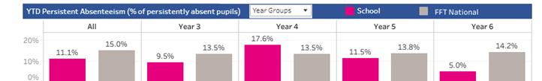  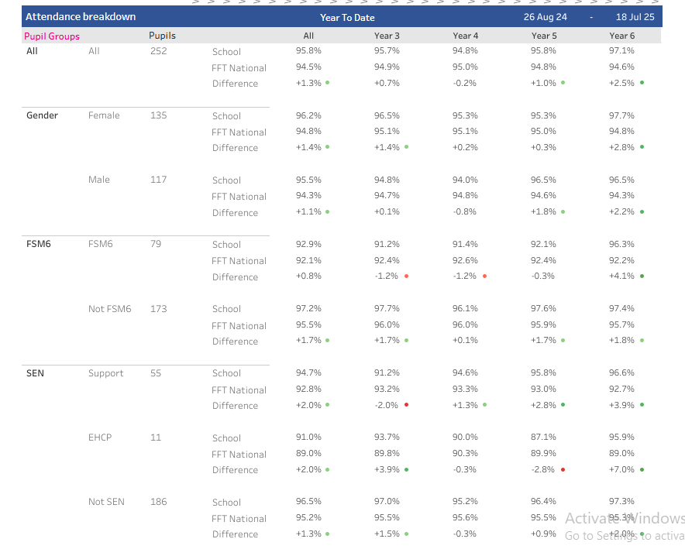

Externally provided programmes
Please include the names of any non-DfE programmes that you purchased in the previous academic year. This will help the Department for Education identify which ones are popular in England
Programme | Provider
N/A

Service pupil premium funding (optional)

Programme | Provider
N/A

Further information (optional)
Planning, implementation, and evaluation
In planning our pupil premium strategy, senior leaders attend HIAS pupil premium strategy meetings, which act as a useful source of thinking about strategy, gathering information and resources. In addition we triangulate evidence from multiple sources of data including assessments, engagement in class book scrutiny, and conversations with stakeholders in order to identify the challenges faced by disadvantaged pupils. We looked at a number of reports (particularly from the Education, Endowment Foundation EEF), studies and research papers about effective use of pupil premium, the impact of disadvantage on education outcomes and how to address challenges to learning presented by socio-economic disadvantage. We also looked at studies about the impact of the pandemic on disadvantaged pupils.
We used the EEF’s implementation guidance to help us develop our strategy, to help us diagnose specific pupil needs and work out which activities and approaches are likely to work in our school. We will continue to use it through the implementation of activities.
Our pupil premium strategy will be supplemented by additional activity that is not being funded by pupil premium or recovery premium. That will include:
- Offering a wide range of high-quality extracurricular activities to boost wellbeing, behaviour, attendance, and aspiration through our school societies that every child in school attend.
- General school activities such as Trick box which will focus on building life skills such as confidence, resilience, and socialising.

