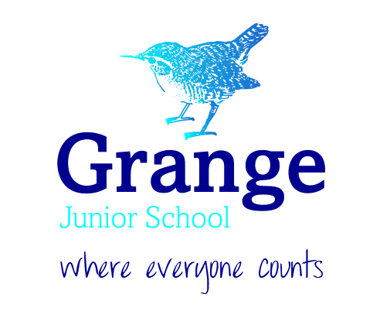

ENSURING EQUALITY OF OPPORTUNITY AND PARTICIPATION STATEMENT

Policy/statement  Ratified | Annual | Nov 10, Nov 13 Mar 18, Mar 19, Mar 20, Mar 22, Mar 23, Mar 24  Mar 25, Mar 26
Equality information  Appendix A | Annual | Sep 2017, Mar 18, Mar 19, Mar 20, Mar 22, Mar 23, Mar 24, Mar 25, Mar 26
Equality objectives  Appendix B | 4 years | March 2016, March 2018  March 2022  March 2024

Our aim
At Grange Community Junior School, we strive to break down any barriers to learning and provide high quality teaching which will inspire and motivate children to engage in their learning and be prepared for the ever-changing world ahead of them. We commit ourselves to our own development, always seeking to improve our practice. We aim to provide pupils with the tools for learning and first-hand experiences, we aim for our teaching to lead to learning that is real, relevant and will support our children to leave primary school equipped for life: able to make their own informed choices, with the skills and mind set to thrive, live happy, healthy lives and take on the world.

Our aims for equality
- To ensure all pupils, families and staff are treated equally and that we comply with our duties under the Equality Act 2010;
- To ensure that policies, procedures and practice take into account diversity and to ensure that every effort is made to remove barriers so that there is equality for all;
- To foster positive attitudes and relationships, and a shared sense of community cohesion, identity and belonging, ensuring that difference is appreciated and similarities are valued;
- To promote an environment where all members of the school community can thrive;
- To promote positive attitudes and interaction between members of the school community, and to promote effective teamwork through mutual support and cooperation;
- To ensure that our policies and practices for all staff and potential staff throughout the employment lifecycle, i.e. from recruitment through to the cessation of employment and beyond, are applied fairly and consistently across all groups with full respect for legal rights, taking into account aspects applicable to particular groups (e.g. duty to make reasonable adjustments for disabled staff).

Our ethos
Our ethos at Grange Community Junior School is based on inclusivity. Everyone in our school community is cared for and valued equally as a unique person. We believe that the ethos creates an environment where all members of our community can learn. We know that by working in partnership in a positive, caring and supportive environment, people develop a sense of belonging and feel valued. We understand the impact of self-esteem on motivation and the ability to learn.

Our values
Our seven school values underpin the learning and social behaviours that we expect all members of our school community to demonstrate. The values of Participate, Excel and be Proud are the school’s golden threads which permeate all aspects of school life.
Proud | Excel | Resilience | Participate | Respect | Integrity | Collaborate
Recognise your own success so that you can enjoy being your best | You can successfully be your best when you try your best | Keep on trying to achieve your best no matter what | Build your best by engaging in your learning | Be the best by being kind and caring to others, your school and yourself | Do your best even when no one is watching you | Work together to achieve your best

These Values have been chosen to develop pupils both morally and educationally. Through the values we:

- Enable children to focus upon the positive aspects of themselves, reminding them of their individual worth, their worth in the school and wider community
- Maintain high standards of behaviour, conduct and self-confidence
- Raise standards by promoting an inclusive ethos which supports the development of the whole child as a reflective learner within a calm, caring, happy and purposeful atmosphere
- Encourage children to ‘live the values’ in all aspects of their lives both in school and out.
Our values are underpinned by fundamental British values.
- Democracy: We all have a say.
- Rule of Law: We respect the rules of school and laws in society.
- Tolerance of different cultures: We are one community who care, respect and understand one another.
- Mutual respect: We respect others and expect them to show us respect.
- Individual liberty: We know human rights and exercise these in school life and beyond.

National and legal context
There are a number of statutory duties that must be met by every school in line with legislation from the Race Relations (Amendment) Act (2000), Disability Equality Duty (2005) and Equality Act (2010).
We recognise that we have duties under the Equality Act 2010 in relation to the school community to eliminate discrimination, advance equality of opportunity and foster good relations in relation to age (applicable only to staff), disability, ethnicity, gender (including issues of transgender, maternity and pregnancy), religion and belief, sexual orientation and marital status (applicable only to staff).
We also recognise that we have a duty under the Education and Inspections Act 2006 to promote community cohesion, i.e. developing good relations across different cultures and groups.
We also appreciate that these duties reflect the international human rights standards as expressed in the UN Convention on Rights of the Child, the UN Convention on the Rights of People with Disabilities, and the Human Rights Act 1998.

The general duty:
The three aims of the “general duty” require the school to:
- Eliminate unlawful discrimination, harassment and victimisation and other conduct prohibited by the Act;
- Advance equality of opportunity between people who share a protected characteristic and those who do not;
- Foster good relations between people who share a protected characteristic and those who do not.
The protected characteristics are: age, disability, gender reassignment, pregnancy and maternity, race, religion or belief, sex and sexual orientation. The school also needs to have due regard to the need to eliminate unlawful discrimination against someone because of their marriage or civil partnership status. The first aim of the duty applies to this characteristic but the other aims (advancing equality and fostering good relations) do not apply.

Age, gender reassignment, pregnancy and maternity, sexual orientation and marriage or civil partnership status will be relevant characteristics in the school’s role as an employer and service provider but not in relation to pupils

The specific duties:
The school is required to publish:
- Information to demonstrate its compliance with the general equality duty;
- One or more equality objectives.
The information will need to be published annually and the objectives at least every four years.

As the school has fewer than 150 employees, it is not required to publish information relating to staff.

School context
Grange Community Junior School is a local authority mainstream two-form entry junior school in Farnborough, Hampshire, in the borough of Rushmoor. The community the school serves is diverse. Whilst we recognise that all groups of children, whether a significant group or not, have equal rights, significant groups within our school include:
SEND (on average 23%)
Pupil premium (on average 35%)
Vulnerable children (on average 40%)
Children from lower socio-economic backgrounds
Children who enter school part way through the academic year
Children who have had a social worker

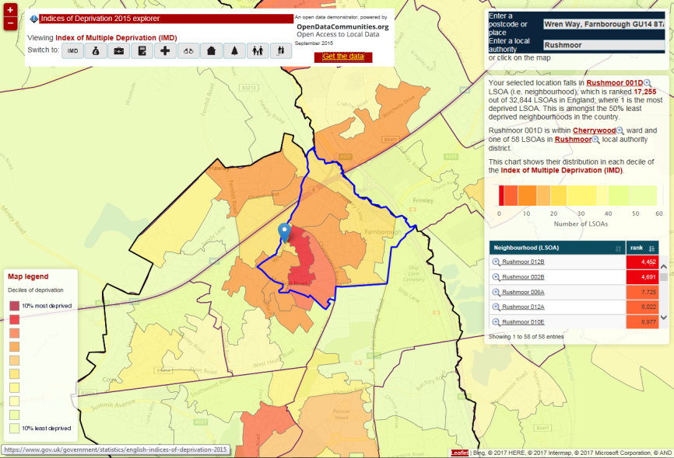

Principles
To fulfil our legal obligations, we are guided by a number of principles.

1. All pupils, families and staff are of equal value
We see all pupils, potential pupils, their parents and carers, and staff as of equal value:
- Whether or not they are disabled
- Whatever their ethnicity, culture, national origin or national status
- Whatever their gender and gender identity
- Whatever their religious and non-religious affiliation or faith background
- Whatever their sexual orientation
- Whatever their marital status
- Whether they are currently pregnant or have recently given birth
- Whatever their age
- Whether or not English is their first language

2. We recognise and respect difference

We recognise that treating people equally does not necessarily involve treating them all the same. We recognise that our policies, procedures and activities must not discriminate but must take account of diversity and the kinds of barriers and disadvantage that staff, parents/carers or pupils may face in relation to their protected characteristics:
- Disability – we note that reasonable adjustments may need to be made
- Gender (including transgender) – we recognise that girls and boys, men and women have different needs
- Religion and belief – we note that reasonable requests in relation to religious observance and practice may need to be made and complied with
- Ethnicity and race – we note that all have different experiences as a result of our ethnic and racial backgrounds
- Age – we value the diversity in age of staff, parents and carers
- Sexual orientation – we respect that individuals have the right to determine their own sexual identity and that they should not experience disadvantage as a result of their preference
- Marital status – we recognise that our staff, parents and carers may make their own personal choices in respect of personal relationships and that they should not experience disadvantage as a result of the relationships they have
- Pregnancy and maternity – we believe that our staff, parents and carers should not experience any unfair disadvantage as a result of pregnancy or having recently given birth

3. We foster positive attitudes and relationships, and a shared sense of cohesion and belonging

We intend that our policies, procedures and activities should promote:
- positive attitudes and interaction between groups and communities different from each other
- an absence of harassment, victimisation and discrimination in relation to any protected characteristics

4. We observe good equalities practice in relation to staff

We ensure that our policies and practices for all staff and potential staff throughout the employment lifecycle, i.e., from recruitment through to the cessation of employment and beyond, are applied fairly and consistently across all groups with full respect for legal rights, taking into account aspects applicable to particular groups (e.g. duty to make reasonable adjustments for disabled staff).

5. We aim to reduce and remove inequalities and barriers that already exist

6. We aim to foster community cohesion. We intend that our policies, activities and curriculum offer foster greater social cohesion and provide for an equal opportunity to participate in public life irrespective of the protected characteristics of individuals and groups.

7. We base our practices on sound evidence

We maintain and publish information annually to show our compliance with the public sector equality duty, set out under section 149 of the Equality Act 2010. Our current equality information can be found in Appendix A to this policy statement.

8. We set ourselves specific and measurable equality objectives
We develop and publish specific and measurable objectives every four years which can be found in Appendix B.

Application of the principles within this policy
The school will ensure that:

- Pupil achievement is monitored by race, gender and disability and any trends or patterns in the data that may require additional action to narrow the gap are addressed
- All staff are aware of the school’s Equality Policy
- There is an inclusive approach to ensuring all pupils are given the opportunity to make a positive contribution to the life of the school e.g., through involvement in the School Council by election or co-option), taking part in class assemblies, taking part in fund raising events etc;
- Disabled children can take part in all aspects of the curriculum, including educational visits, lunchtime activities, PE and assemblies
- Staff, pupils, parents and carers will continue to be involved in the future development of the Equality Policy, which may include input through and feedback from any surveys, staff meetings, school council meetings, parents’ evenings etc.
- Extended school activities such as breakfast and after-school clubs take into account pupil needs and access issues and pupils attending reflect the diversity of the school population in terms of race, gender, disability and socio-economic status

The school will provide:

- Extra and additional support for pupils who are under-achieving, in order to make progress in their learning and their personal well-being e.g. ensuring that children with visual impairment have accessible texts
- Additional support for parents of under-achieving children (e.g., reporting progress and discussing needs in addition to routine parents’ evenings)
- Additional support for disabled parents/carers and staff to help them to play a full part in the life of the school (e.g., providing an interpreter for Nepalese parents; ensuring that meetings are held in the most accessible parts of the school to support wheelchair users).

Promoting positive attitudes

The school will:

- Promote positive images which reflect the diversity of the school and community in terms of race, gender and disability, for example in assemblies, books, publications and learning materials and in classroom/corridor display.
- Seek to recruit disabled people (where fitting of criteria) to the school and support them in their work and career development, and try to reflect the diversity of the school community in its workforce
- Seek to recruit disabled people (where they apply) to the governing body and make reasonable adjustments to ensure that they can fully participate and contribute
- Provide reasonable means for children, their friends and families to interact with people from different backgrounds and build positive relationships
- Provide extended services (where possible), with opportunities for pupils, families and the wider community to take part in activities and receive services which build positive interaction and achievement for all groups
- Support disabled pupils in the period of transition between infant – junior and primary- secondary school to ease the stress of moving and increase familiarity with new surroundings
- Help children and young people to understand others and value diversity
- Promote the school shared values
- Develop skills of responsible action – for example through PHSCE lessons and assemblies.

Eliminating discrimination and harassment

The school will:

- Ensure anti-bullying procedures include equality perspectives
- Support staff to challenge and address any bullying and harassment that is based on a person’s race, gender or ethnicity
- Keep a record and report how these incidents are dealt with to the Governing Body and local authority on a regular basis
- Review the school approach to race, gender and disability bullying and harassment whenever it reviews its policies where this may be included e.g. equality of opportunity

Roles and responsibilities
The governing body is responsible for ensuring that the school complies with legislation, and that this policy and its related procedures and action plans are implemented and that arrangements are in place to deal with any concerns or unlawful action that arises.
The head teacher is responsible for implementation of this policy, ensuring that all staff are aware of their responsibilities and given appropriate training and support and for taking appropriate action in any cases of unlawful discrimination, harassment or victimisation.
All staff are expected to work in accordance with the principles outlined in this policy to:
- promote an inclusive and collaborative ethos in their practice
- deal with any prejudice-related incidents that may occur
- plan and deliver curricula and lessons
- support pupils in their class who have additional needs
Other policies which support the Equalities Policy include:
- Admissions
- Anti-bullying
- Behaviour
- SEND Information report
- Accessibility Plan

Appendix A:
Grange Community Junior School Equalities information
The public sector equality Duty 2011 has three aims under the general duty for school:

-Eliminate unlawful discrimination, harassment and victimisation and other conduct prohibited by the Act
-Advance equality of opportunity between people who share a protected characteristic and those who do not
-Foster good relations between people who share a protected characteristic and those who do not

We have considered how well we currently achieve these aims with regard to the protected groups under the Equality Act (race, disability, gender, gender re-assignment, age, pregnancy and maternity, marital status, sexual orientation, religion and belief and sexual orientation. Age and marriage not applicable to children.)

As the school has less than 150 staff, we will not publish information with regard to staff.

Pupil-related data
Information | Evidence and commentary
Pupils on roll 2024-25 academic year | 235 pupils in total  46% boys and 54% girls
English not as first language | 108 pupils 46%
SEN | 62 pupils 26% This includes 11 EHCPs (3.8%)
Attainment by KS 2 by gender 2025 (60 pupils 29 boys and 31 girls) | Reading 76% boys 94% girls  Writing 69% boys 94% girls  Maths 83% boys 90% girls
Pupils in receipt of PPG | 30% of whole school
Participation in extracurricular clubs. Spring term 2025
  club | %girls | %boys | %white UK | %other ethnicity
  Y3 football
  Y4 football
  Year 5/6 football
  Netball
  Fun, fit + yoga
  Dance
  choir
  Rocksteady
  Guitar
Participation in the School Council pupil voted positions of responsibility by gender and ethnicity 2025-26 | School councillors  29% are boys and 71% are girls  42% are white UK, 25% white other, 33% other ethnicity
Participation as House Captains pupil voted positions of responsibility by gender and ethnicity 2025-26 | House Captains  50% are boys and 50% are girls  63% white UK, 12% white other, 25% other ethnicity
100% Attendance by gender 2024-25 | 96% girls achieved 95% 96% boys achieved 95% attendance  26 pupils with 100% this academic year. Of the children with 100% attendance:  (17) are girls and (9) are boys  10 (38%) are White UK, 16 (62%)other ethnicity.
Attainment 2025
 | No. | Reading |  | Writing |  | Maths |  | RWM
Group | 60 | School | National | School | National | School | National | School | National
All | 60 | 86% | 75% | 83% | 72% | 88% | 74% | 73% | 62%
Boys | 29 | 75.9% | 72.1% | 69.0% | 66.4% | 82.8% | 74.8% | 58.6% | 59.1%
Girls | 31 | 93.5% | 78.2% | 93.5% | 78.5% | 90.3% | 73.3% | 83.9% | 65.5%
Disad | 20 | 75% | 60% | 65% | 53.4% | 85% | 56.4% | 65% | 40.9%
FSM | 20 | 75% | 60% | 65% | 53.4% | 85% | 56.4% | 65% | 40.9%
SEN | 19 | 68.4% | 42.4% | 42.1% | 32.3% | 57.9% | 39.6% | 26.3% | 23.8%
No SEN | 41 | 92.7% | 84.5% | 100% | 83.7% | 100% | 84% | 92.7% | 73.2%
English first lang | 32 | 78.1% | 75.7% | 65.6% | 72.2% | 81.3% | 73.1% | 59.4% | 61.7%
EAL | 28 | 92.9% | 73.9% | 100% | 73.2% | 92.9% | 78% | 85.7% | 64.5

Appendix B
Grange Community Junior School Equalities objectives
- Promotion of Equality, diversity and inclusion
To ensure the school actively promotes and prioritises raising awareness, appreciation and celebration of diversity including gender, sexuality, race and religion.
Strategy | Success criteria | Responsibility | Timescale | Evaluation
Embedded within the school’s culture, curriculum, policies, and day-to-day interactions strategy for actively promoting and prioritizing diversity, equity, and inclusion.  Review of RE and PSHE texts to support teachers and pupils in the exploration of key themes and in their developing spiritual, moral, social and cultural understanding. | To raise awareness of the protected characteristics alongside key issues pertaining to Equality, Diversity and Inclusion. | LW PB  EB- library | As curriculum is being reviewed | - Statements about inclusion appear within the schools’ vision, values and policies.  - Regularly review policies, curriculum, and practices to ensure ongoing improvement  - Anti-bullying policy ensuring swift action taken against incidents  - A strong reporting system in place where students feel safe to report discrimination.  - Curriculum reflects diverse perspectives e.g. history, RE  - In 24-25 staff CPD around inclusion through the TSEND modules.  - In 24-25 CPD twilight session on HQIT with a focus upon equity.  - In 24-25 New units added to PSHE to help inform economic wellbeing and equality ensure that the pupils are more aware of differences and how we should treat one another.  - Recommended reads for year group have been carefully selected by library manager to reflect diversity of authors and characters  - Library has collection of books which represent diverse people  - Black history month lessons take place  - Religious festivals from across many religions celebrated in assembly e.g. Eid, Diwali, Easter

- Pupil attainment and disadvantage
To mitigate the attainment gap between disadvantaged and non-disadvantaged pupils
Strategy | Success criteria | Responsibility | Timescale | Evaluation
Effectively utilise funding streams such as Pupil Premium Grant and Catch Up/Recovery Premiums to focus upon EEF recommended strategies (Teaching and Whole School Strategies, Targeted Support and Wider Strategies). Implement PPG and Catch Up/Recovery Strategy Statements successfully through regular monitoring, ensuring they have the desired impact upon pupils. | Ensure adaptive teaching strategies are embedded so lessons meet the needs of all learners, particularly those with SEND and disadvantaged backgrounds.  The gap between the attainment of disadvantaged and all pupils closes. | LW PB | Annual cycle of review | - Prioritise excellent teaching by investing in CPD for teachers. In 24-25 staff CPD around inclusion through the TSEND modules.  - In 24-25 CPD twilight session on HQIT with a focus upon equity  - Teachers implement scaffolding, pre-teaching, and retrieval practice to help disadvantaged pupils retain key knowledge.  - Teachers use explicit vocabulary instruction to bridge language gaps that may affect learning.  - Teachers utilise teaching assistants effectively, focusing on targeted interventions rather than solely on general classroom support. PM interventions are timetabled.  - PP strategy in place. Ensure funding is targeted strategically, based on research (e.g., Education Endowment Foundation’s guidance).  - Monitoring occurs regularly. Updates made to assessment and recording systems to ensure data is thoroughly analysed and clear actions identified.  - Y6 booster groups for SATs  Data Autumn 24  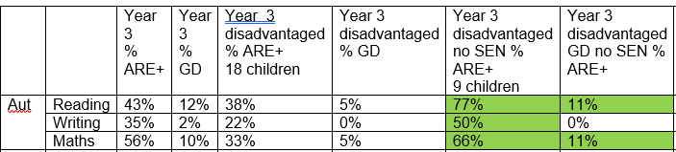  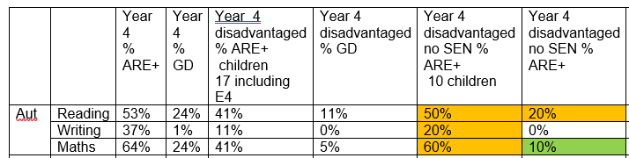  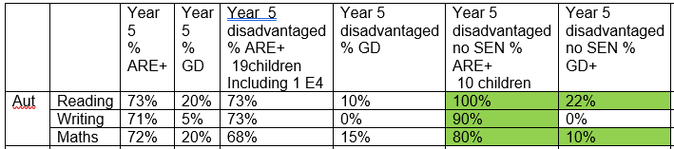  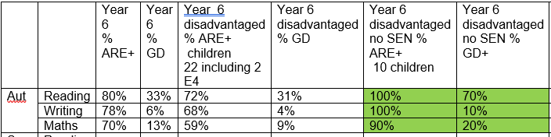  Data SATs 2025 for pupils in receipt of PPG
  PPG | Reading |  | Writing |  | Maths |  | RWM
   | School | National | School | National | School | National | School | National
   | 75% | 60% | 65% | 53% | 85% | 56% | 65% | 40%

- Pupil Attainment and Progress/Gender, Race and Disability
To monitor and analyse pupil achievement by race, gender and disability and act on any trends or patterns in the data that require additional support for pupils.
Strategy | Success criteria | Responsibility | Timescale | Evaluation
The progress of all groups will be continuously tracked. Appropriate support is targeted where necessary to ensure that all groups make at least good progress. Targeted interventions will be tracked to ensure pupils make progress to align with their peers. | Data analysis will show equality of attainment/progress for all groups in relation to their starting points. | SLT | Ongoing | - SLT promote high expectations for all pupils  - We regularly collect and analyse pupil achievement data by race, gender, disability, SEND, EAL, and Pupil Premium status.  - We analyse attainment and progress patterns to spot disparities between groups.  - Where gaps exist, implement tailored support strategies, such as: Small-group or one-to-one (e.g., targeted literacy/numeracy interventions).  - Teachers adapt SEND provision to ensure pupils with disabilities have full access to learning.  - Booster sessions for Y6 .  - Homework club to support those pupils who need it  - Reading teacher to focus on those pupils making least progress  - Ensure pupil voice is included—EMU time gather feedback from pupils about their learning experiences.  - Changes to practice in Autumn 2025 to gather data quickly and give immediate feedback to those pupils who are in most need

4.Pupil Attendance
To monitor and analyse pupil attendance by race, gender and disability and act on any trends or patterns in the data that require additional support for pupils.
Strategy | Success criteria | Responsibility | Timescale | Evaluation
The attendance of all groups will be continuously tracked. Targeted support will be to given to ensure pupils with low attendance align with their peers. | Increase attendance for pupils highlighted with low attendance | SLT | Ongoing | - Implement strong attendance monitoring, ensuring early intervention for persistent absenteeism. Regular monthly checks and parents’ meetings set up  - Provide breakfast clubs and after-school activities to promote attendance and engagement.  - In Spring 2025 employment of FSW to ensure stronger focus on working with families with lower attendance. This has had good results with some families.  - In 2024-25 FFT certificate for being in top 25% nationally of schools for attendance

5. Linked to Prejudice-Related Incidents/Sexual Orientation
Raise awareness of sexual orientation and promote positive attitudes towards alternative lifestyles and lessen the chances of the word ‘Gay’ being used negatively.
Strategy | Success criteria | Responsibility | Timescale | Evaluation
Continue to implement our PSHE programme which raises children’s awareness that there are many different family situations. This is not done in isolation. When discussing similarity and difference in PSHE lessons, children learn about a whole range of differences, such as difference in physical appearance and personality, likes and dislikes, and that people can have differences of opinion. This helps them to understand that we are all unique human beings. Within the context of these lessons they will also be introduced to different cultures and ethnicities, people with different religions and beliefs, and about people with disability or special needs. They will also be aware that some people are LGBTQ.  When discussing any differences between people, our PSHE sessions help teach children to form opinions about others based on whether they are kind, law-abiding, respectful, trustworthy, and responsible people, rather than judging them on appearance or whether a particular aspect of their lifestyle is different to their own. Children also learn about discrimination and prejudice including racism, sexism, and ageism. This supports the school with our obligation to align with the Equality Act 2010. We aim to introduce a series of books, which show different family make-ups. This will include same sex couples. The books will be introduced into our normal range of books and will be looked at as part of PSHE sessions and other shared reading opportunities. We will also place some in our library. | To raise awareness of this protected characteristic and to reduce the number of prejudice-related incidents. | SLT | Ongoing | - Embed inclusivity in the school’s vision, values, and policies, ensuring all pupils feel respected.  - Books in the library that depict diverse families and relationships in an age-appropriate way.  - Set clear expectations that all forms of discriminatory language, including the misuse of ‘gay’, are unacceptable. Monitoring to pick up and deal with any prejudicial language.  - RSE policy reviewed and sent to parents for comment  - Teach about different family structures in PSHE and relationships education (e.g., "Some RSE work on families;children have a mum and dad, some have two mums or two dads, some live with grandparents or carers").

